**Create And Configure IBM Cloud services**

Create IBM Watson IOT Platform And Device

**Step-1**

Create Internet of Things Platform 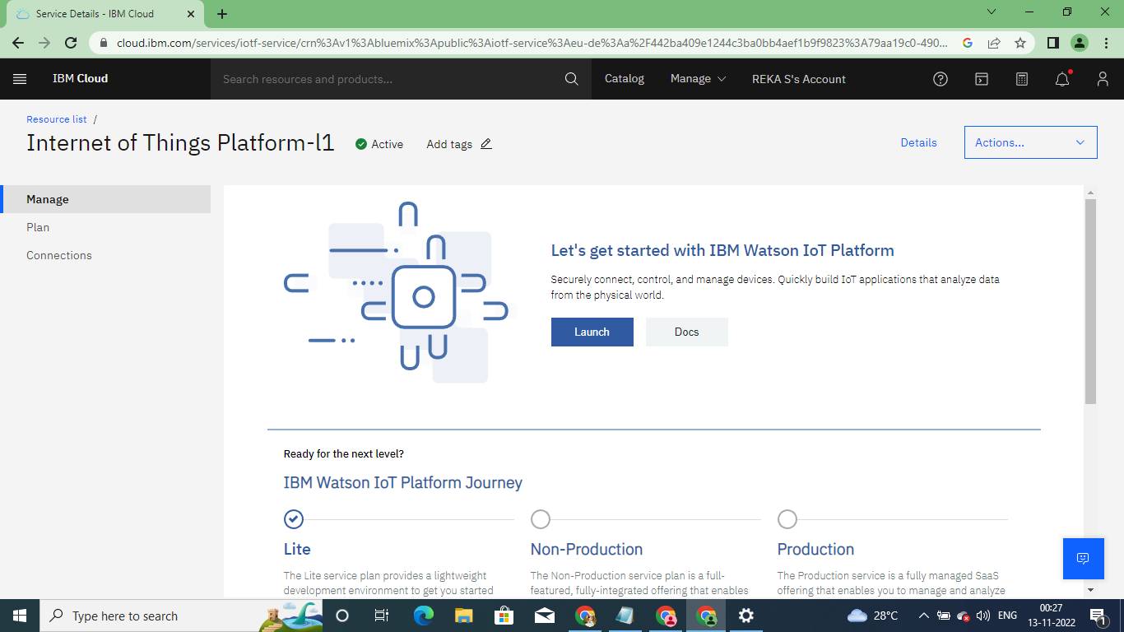

Click on Launch

Next Create IBM Watson IOT Platform

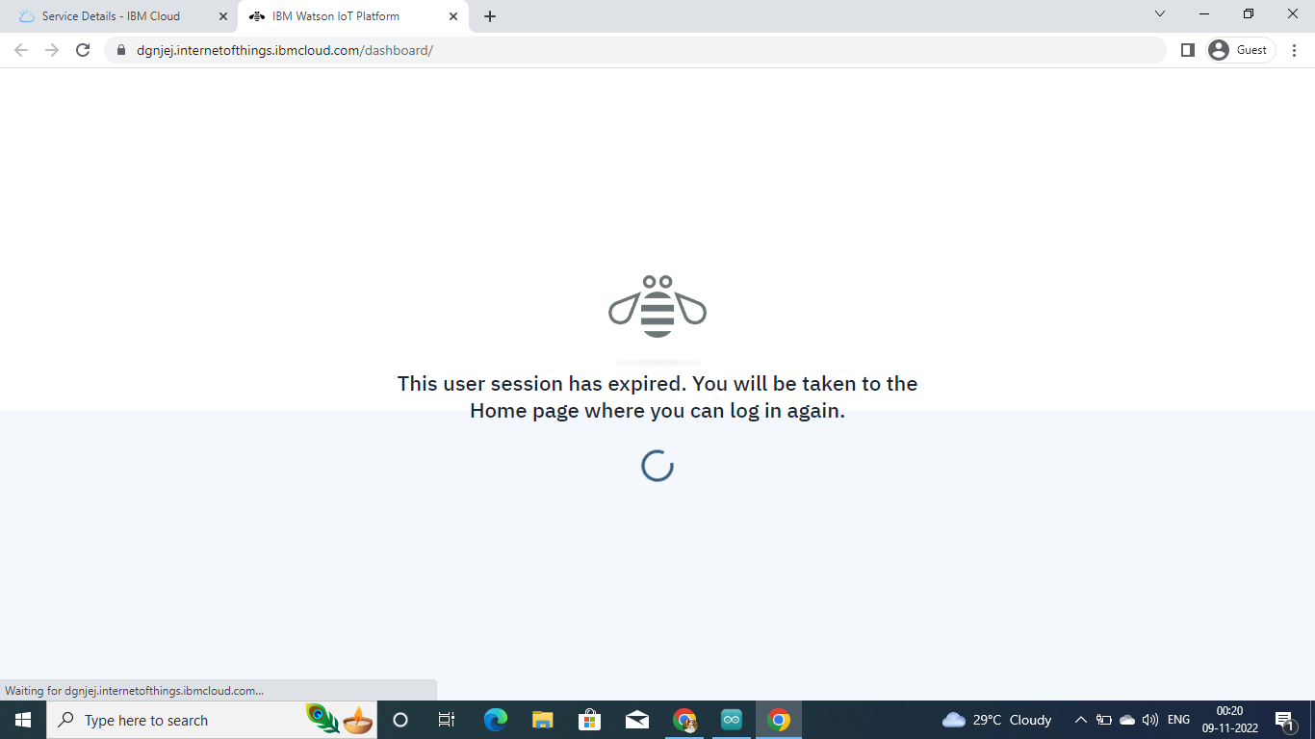

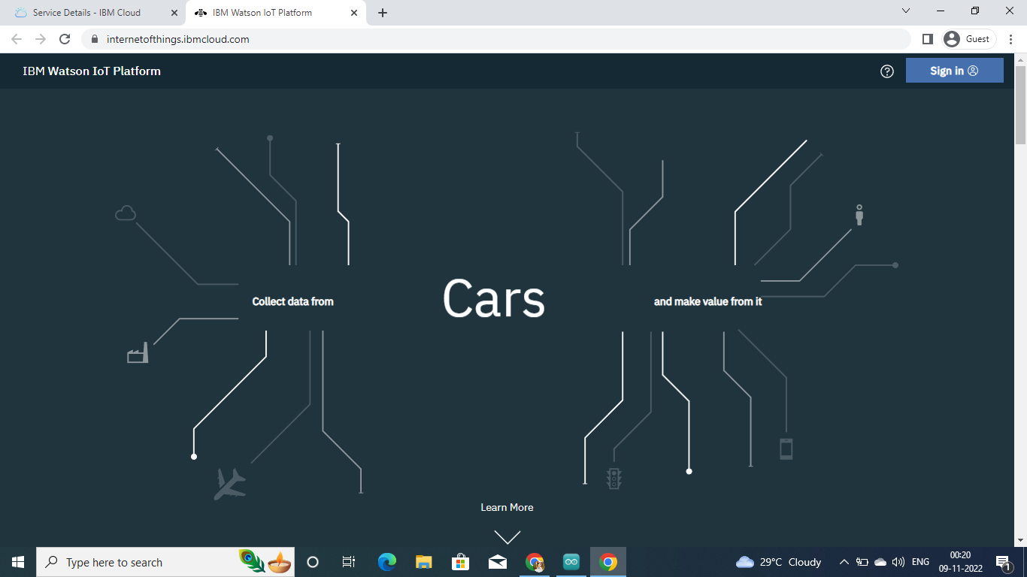

Sign in -IBM Watson IOT Platform

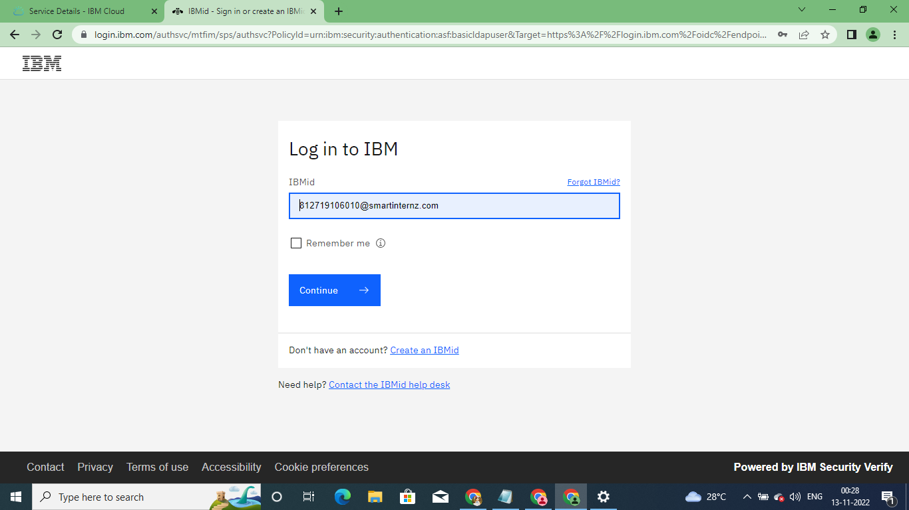

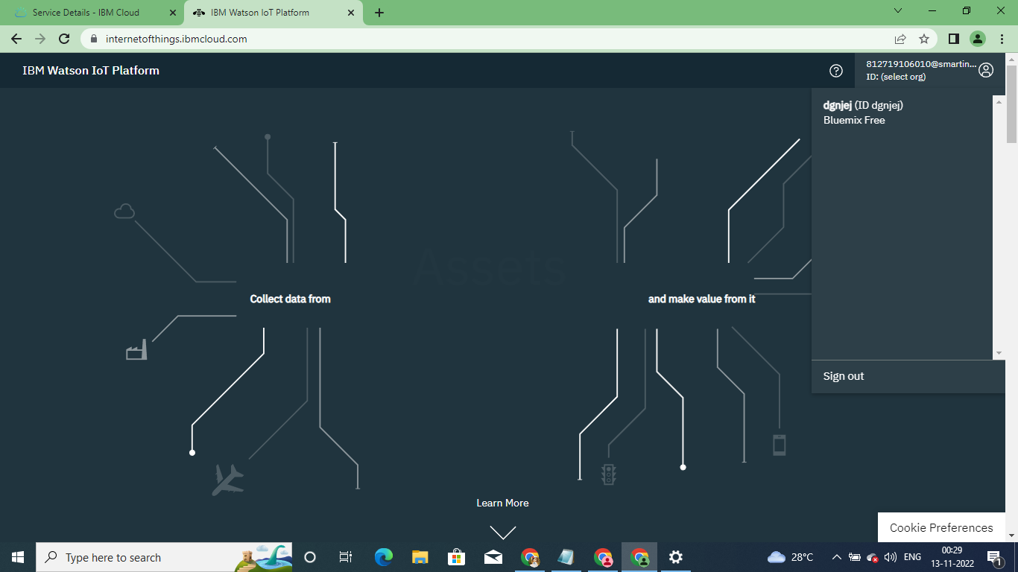

Once sign in IBM Watson IOT Platform

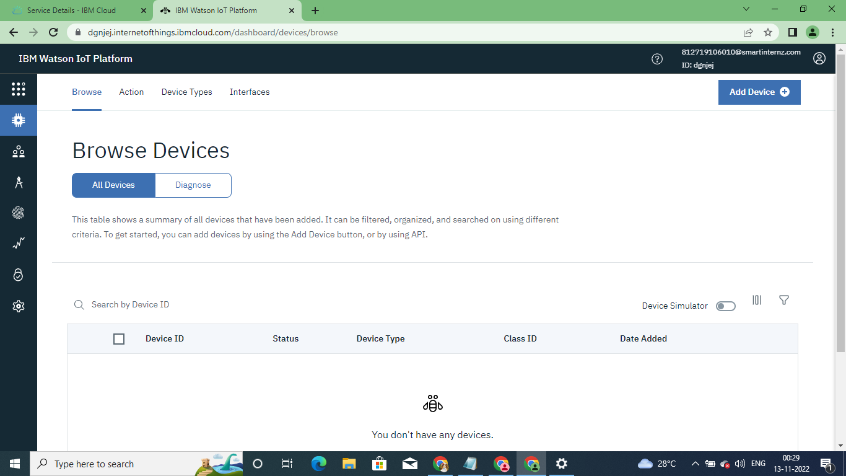

Create a device in the IBM Watson IoT Platform

